Assignment-11.3
Lab 11: Data Structures with AI Implementing Fundamental Data
Structures using AI Assistance
Prompt :
Task-01: # I want build an application Task 1: Smart Contact Manager (Arrays & Linked Lists) Scenario: SR University’s student club requires a simple Contact Manager Application to store members’ names and phone numbers. The system should support efficient addition, searching, and deletion of contacts.
# Tasks: 1. Implement the contact manager using arrays (lists). 2. Implement the same functionality using a linked list for dynamic memory allocation. 3. Implement the following operations in both approaches: Add a contact, Search for a contact, Delete a contact. 4. Use GitHub Copilot to assist in generating search and delete methods.5. Compare array vs. linked list approaches with respect to:, Insertion efficiency, Deletion efficiency
# Expected Outcome ,Two working implementations (array-based and linked-list-based). A brief comparison explaining performance differences.
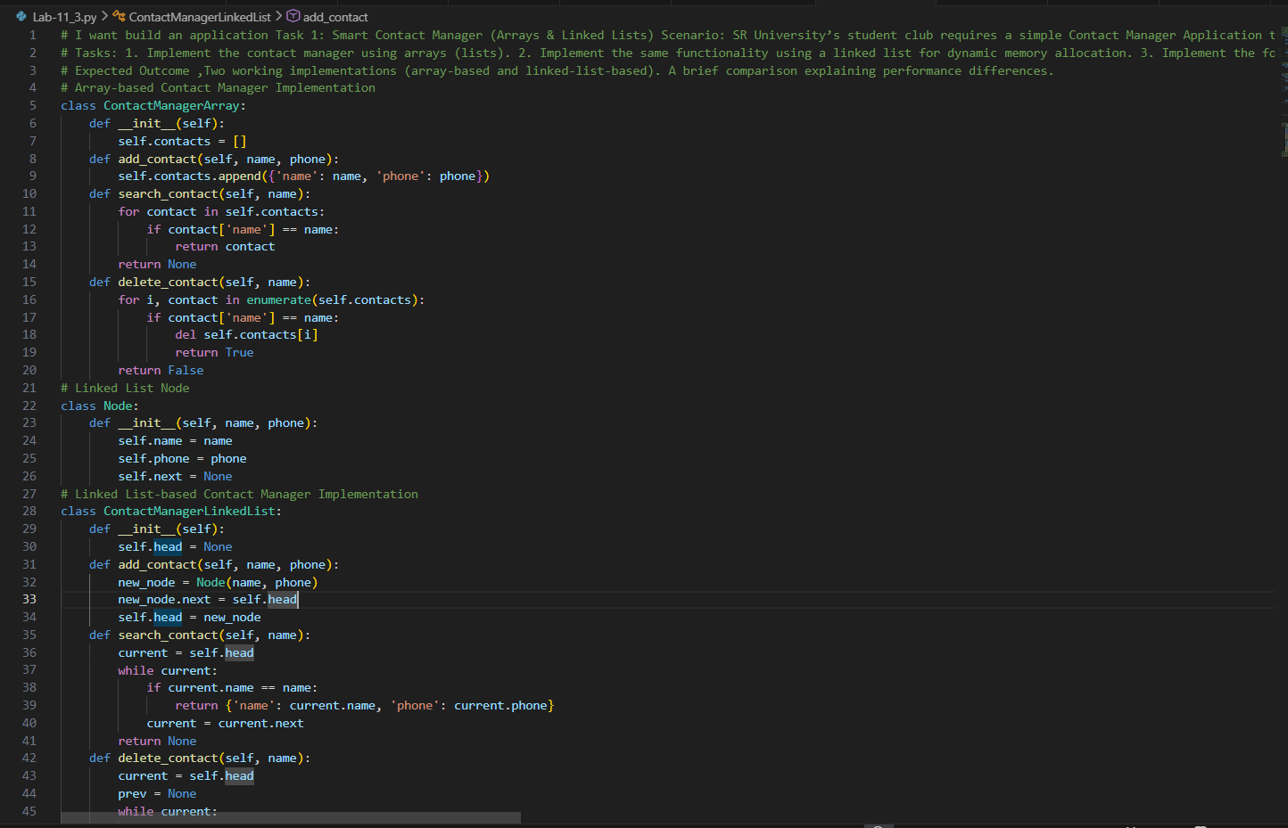

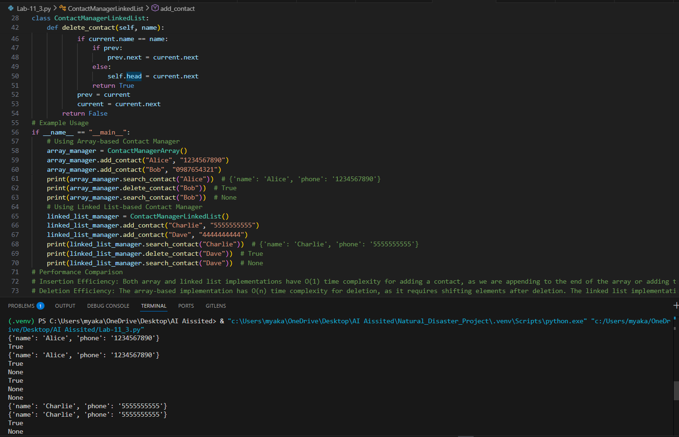
Task-02: Library Book Search System (Queues & Priority Queues). Scenario: The SRU Library manages book borrow requests. Students and faculty submit requests, but faculty requests must be prioritized over student requests.
# Tasks: 1. Implement a Queue (FIFO) to manage book requests. 2. Extend the system to a Priority Queue, prioritizing faculty requests.3. Use GitHub Copilot to assist in generating: enqueue() method, dequeue() method.4. Test the system with a mix of student and faculty requests.
# Expected Outcome: Working queue and priority queue implementations. Correct prioritization of faculty requests.Do the gvien tasks and implement the Queue and Priority Queue for the Library Book Search System.
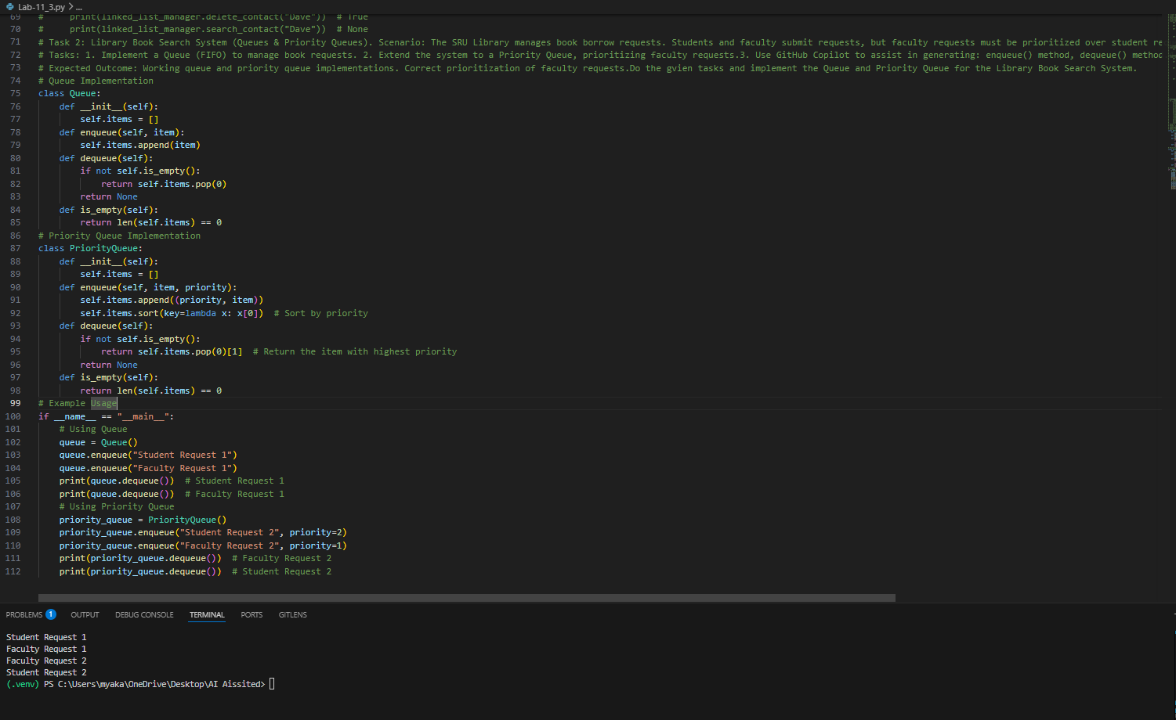
Task-03 :
# Task 3: Emergency Help Desk (Stack Implementation) Scenario: SR University’s IT Help Desk receives technical support tickets from students and staff. While tickets are received sequentially, issue escalation follows a Last-In, First-Out (LIFO) approach.
# Tasks 1. Implement a Stack to manage support tickets. 2. Provide the following operations: push(ticket), pop(), peek(). 3. Simulate at least five tickets being raised and resolved.4. Use GitHub Copilot to suggest additional stack operations such as: Checking whether the stack is empty, Checking whether the stack is full (if applicable)
# Expected Outcome: Functional stack-based ticket management system. Clear demonstration of LIFO behavior. Give the implementation of the Stack for the Emergency Help Desk.
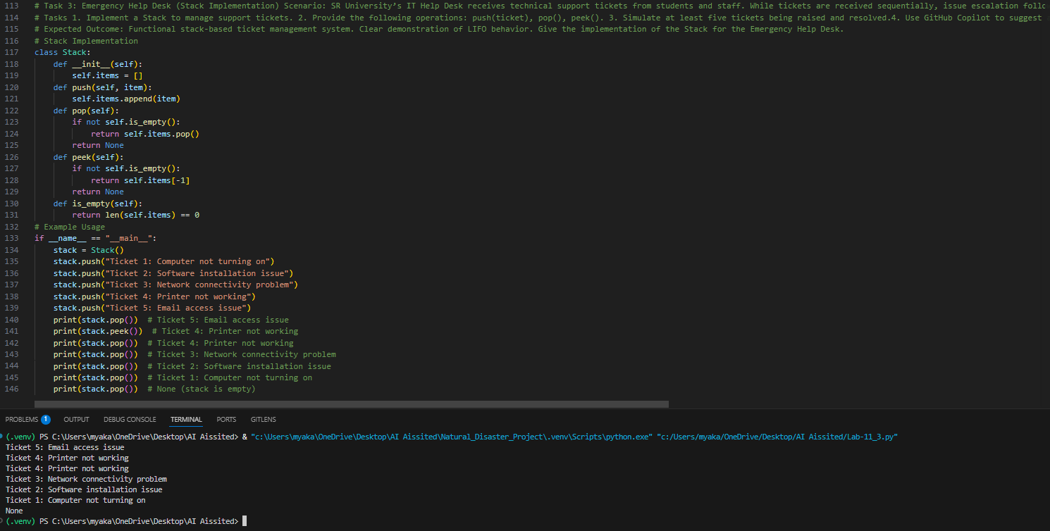
Task 4: Hash Table. Objective To implement a Hash Table and understand collision handling. Task Description Use AI to generate a hash table with: Insert, Search, Delete. Starter Code class HashTable: pass
# Expected Outcome: Collision handling using chaining, Well-commented methods. Generate the implementation of the Hash Table with collision handling using chaining.
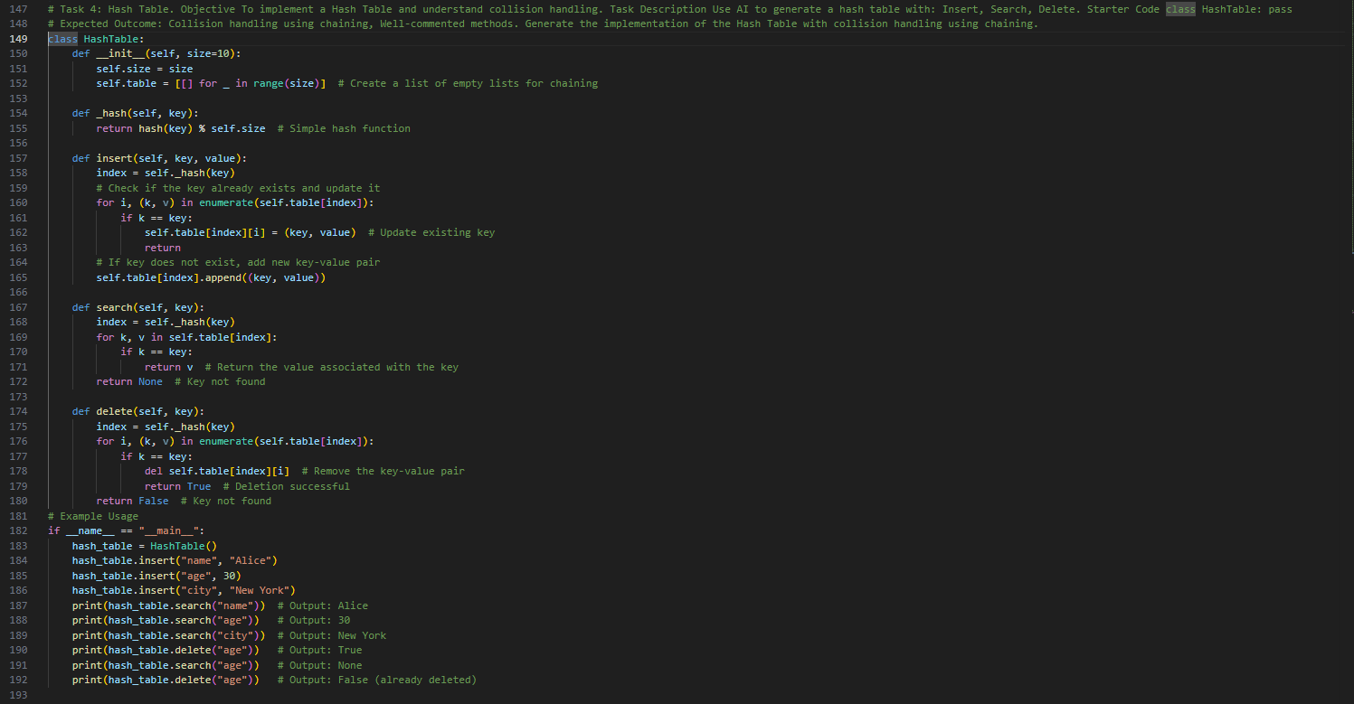
Task-05: Real-Time Application Challenge. Scenario: Design a Campus Resource Management System with the following, features: Student Attendance Tracking, Event Registration System, Library Book Borrowing, Bus Scheduling System, Cafeteria Order Queue
# Student Tasks: 1. Choose the most appropriate data structure for each feature.2. Justify your choice in 2–3 sentences.3. Implement one selected feature using AI-assisted code generation.
# Expected Outcome: Mapping table: Feature → Data Structure → Justification, One fully working Python implementation. Genarate the implementation for the Student Attendance Tracking feature using a suitable data structure.
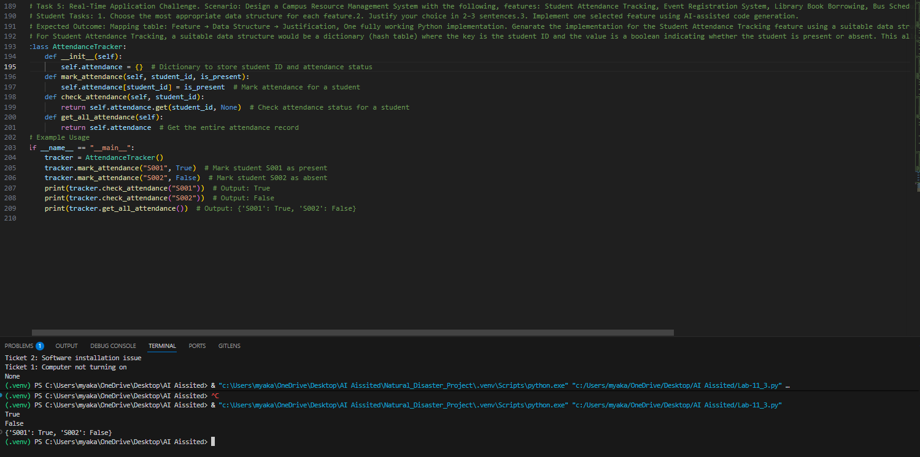
Code Explanation:
# The code implements various data structures to manage different scenarios at SR University.
# Task 1: Contact Manager
# - Two implementations are provided: one using arrays (lists) and another using linked lists.
# - Both implementations support adding, searching, and deleting contacts.
# Task 2: Library Book Search System
# - A Queue is implemented to manage book requests in a First-In, First-Out (FIFO) manner.
# - A Priority Queue is implemented to prioritize faculty requests over student requests.
# Task 3: Emergency Help Desk
# - A Stack is implemented to manage support tickets in a Last-In, First-Out (LIFO) manner.
# Task 4: Hash Table
# - A Hash Table is implemented with collision handling using chaining (lists).
# - It supports inserting, searching, and deleting key-value pairs.
# Task 5: Real-Time Application Challenge
# - The Campus Resource Management System is designed with the following features:
# - Student Attendance Tracking
# - Event Registration System
# - Library Book Borrowing
# - Bus Scheduling System
# - Cafeteria Order Queue
# - The Student Attendance Tracking feature is implemented using a dictionary to efficiently manage attendance records.

